Monte Carlo Inference and the Exploration vs. Exploitation Trade-off

Introduction
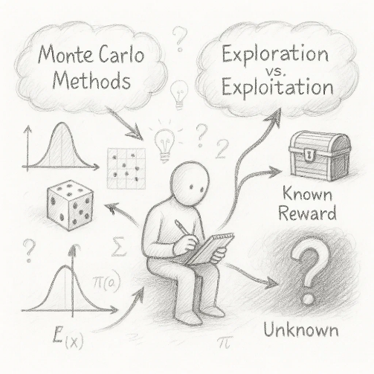
In the age of intelligent systems and complex decision-making, uncertainty is a constant companion. From autonomous vehicles to financial modeling, systems must often make decisions without full knowledge of the world. This uncertainty calls for intelligent estimation and decision strategies.
Monte Carlo inference provides a powerful framework for estimating quantities under uncertainty using randomness. On the other hand, the exploration-exploitation trade-off lies at the heart of intelligent decision-making — how much to explore new options vs. exploiting known good ones.
This assignment explores both concepts deeply, illustrating how they are not only individually powerful but also fundamentally connected in fields like reinforcement learning, Bayesian optimization, and AI research.

1. Fundamentals of Monte Carlo Inference
Monte Carlo inference refers to a class of computational algorithms that use repeated random sampling to estimate unknown quantities. It is especially useful when direct analytical solutions are intractable.

1.1 Core Idea

Suppose we want to compute an expected value:
$$E \left[f\left(x\right)\right]=\int{f\left(x\right)p\left(x\right)dx}$$
If this integral is difficult to solve analytically, we approximate it using random samples:
$$E \left[f\left(x\right)\right]≈\frac{1}{N}\sum_{i=1}^{N}{f\left(x_{i}\right)},x_{i}​∼p\left(x\right)$$
This method is simple yet surprisingly effective, especially in high-dimensional spaces.

1.2 Key Features
- Stochasticity: Uses randomness to approximate results
- Convergence: Accuracy improves as sample size $N$ increases
- Generalization: Can be applied to various distributions and problems

2. Exploration vs. Exploitation Trade-off
At the heart of decision-making lies a dilemma:
- Exploitation: Choose what is already known to yield good results
- Exploration: Try something new to discover potentially better outcomes
Balancing this trade-off is crucial in areas like reinforcement learning (RL), online advertising, and adaptive systems.

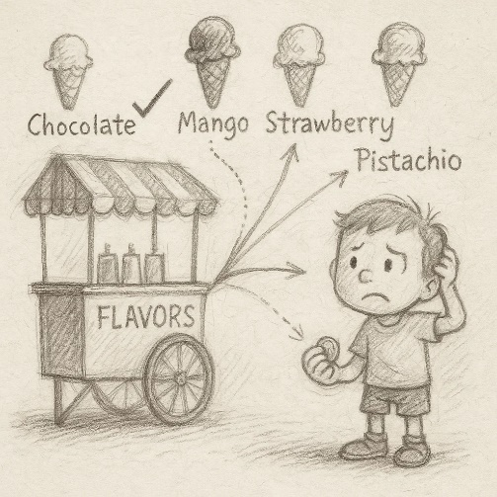
2.1 Conceptual Breakdown
Imagine a child trying ice cream flavors:
- If she always picks chocolate (her known favorite), she’s exploiting
- If she occasionally tries mango or pistachio, she’s exploring
Too much exploitation may miss better options; too much exploration may waste resources on suboptimal choices.

3. Mathematical Perspective

3.1 Monte Carlo Estimation
Let $x_{1}​,x_{2}​,…,x_{n}​∼p\left(x\right)$.Then,
$$\hat{μ}=\frac{1}{N}=\sum_{i=1}^{N}{f\left(x_{i}\right)}$$

is an unbiased estimator of $μ=E_{p}\left(x\right) \left[f\left(x\right)\right]$. The Law of Large Numbers ensures convergence of $\hat{μ }→$ as N →∞.

3.2 Exploration-Exploitation in Bandit Problems
In a multi-armed bandit (MAB) setup with K arms:
- Let $μ_{k}$​ be the unknown reward for arm k
- At each step, select arm $A_{t}$ to maximize total reward

ε-Greedy Algorithm:
- With probability ε: explore (random arm)
- With probability 1−ε: exploit (best arm so far)

4. Interplay Between Monte Carlo and Exploration-Exploitation
These two ideas connect deeply in probabilistic decision-making.

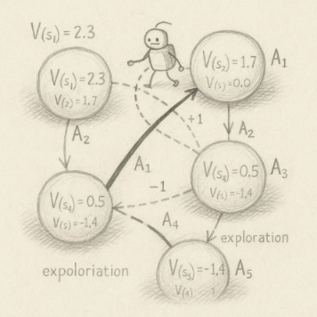
4.1 Monte Carlo in Reinforcement Learning (RL)
In RL, agents must estimate value functions to guide behavior: $V\left(s\right)=E \left[R_{t}\left|S_{t}=s\right.\right]$
Monte Carlo methods estimate these values by simulating episodes and averaging returns — this is a data-driven exploration strategy.
- Early on, exploration gathers diverse episodes
- Later, exploitation relies on refined value estimates

4.2 Monte Carlo Tree Search (MCTS)
MCTS is a decision algorithm used in games like Go or Chess. It balances exploration and exploitation via Upper Confidence Bounds (UCB), guided by Monte Carlo rollouts.
$$UCB=\hat{μ_{i}}+c\sqrt{\frac{\log{n}}{n_{i}}} ​​$$
Where:
- ${\hat{μ}}_{i}$​: estimated reward for node $i$
- $n_{i}$​: number of visits to node $i$
- $n$: total simulations
- $c$: exploration constant
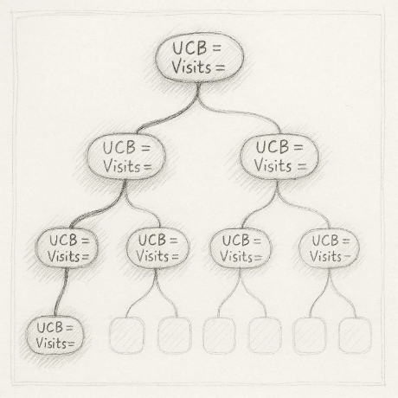
This ensures nodes with high uncertainty get explored while rewarding known good paths.

5. Real-World Applications
- Robotics: Estimating uncertain world models with MC; choosing exploration routes
- Medical Trials: Bandit strategies to allocate patients to treatments
- Finance: Monte Carlo simulations for risk; exploration of new assets
- Recommendation Systems: Balancing known preferences vs. novel suggestions

6. Comparative Analysis of Approaches

Method | Strength | Weakness
Monte Carlo Inference | Simple, flexible | Needs many samples for accuracy
ε-Greedy Exploration | Easy to implement | Poor long-term learning
UCB in Bandits | Balanced trade-off | Needs accurate reward tracking
MCTS | High decision quality | Computationally intensive

7. Limitations and Considerations
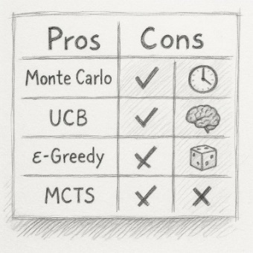
- Monte Carlo: Convergence is slow for complex, high-variance functions
- Exploration: Poor exploration may lead to local optima traps
- Bias-Variance Tradeoff: Over-exploration increases variance, over-exploitation introduces bias

8. Emerging Research Directions
- Bayesian Deep Learning: Using MC Dropout to approximate uncertainty
- Thompson Sampling: Bayesian approach to exploration using posterior sampling
- Meta-RL: Learning how to learn the right balance between exploration and exploitation
- Neural MCTS: Used in AlphaZero to integrate deep learning with tree search

Conclusion
Monte Carlo inference and the exploration-exploitation trade-off are foundational tools in modern intelligent systems. While Monte Carlo empowers us to estimate unknowns using randomness, the trade-off shapes how agents act under uncertainty. Their intersection is rich with powerful methods like MCTS and bandit algorithms.
Understanding these principles equips researchers and practitioners to build smarter, more adaptive algorithms in uncertain environments. As real-world systems become more autonomous, mastering these concepts is not only academically valuable — it’s essential for building the future.

